Project: IST 722 - Data Warehouse

Fudge Inc. Order Fulfillment

1. Source to Target Map – Package of all Packages

1. Date Dimension
   1. SSIS Package to Stage Date Dimension

* 1. Dataflow – Date Dimension

1. Stage Orderfulfill
   1. SSIS Package to Stage Products, Customers, Shippers, OrderFulfill

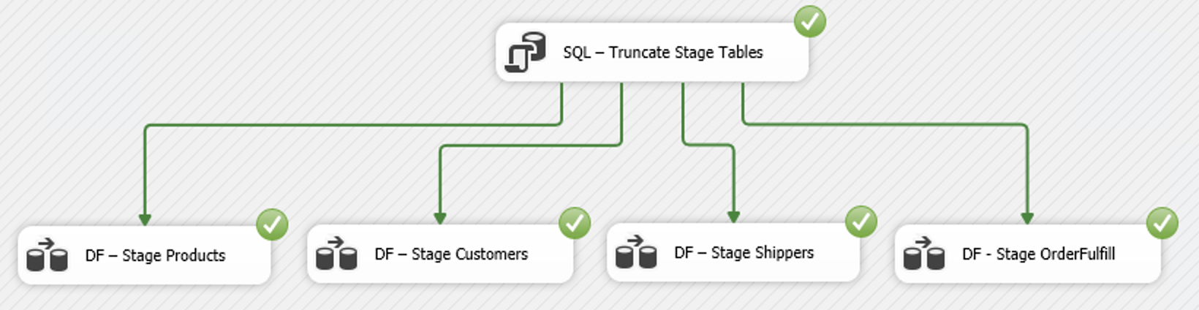

* 1. Dataflow – OLTP to Stage Products

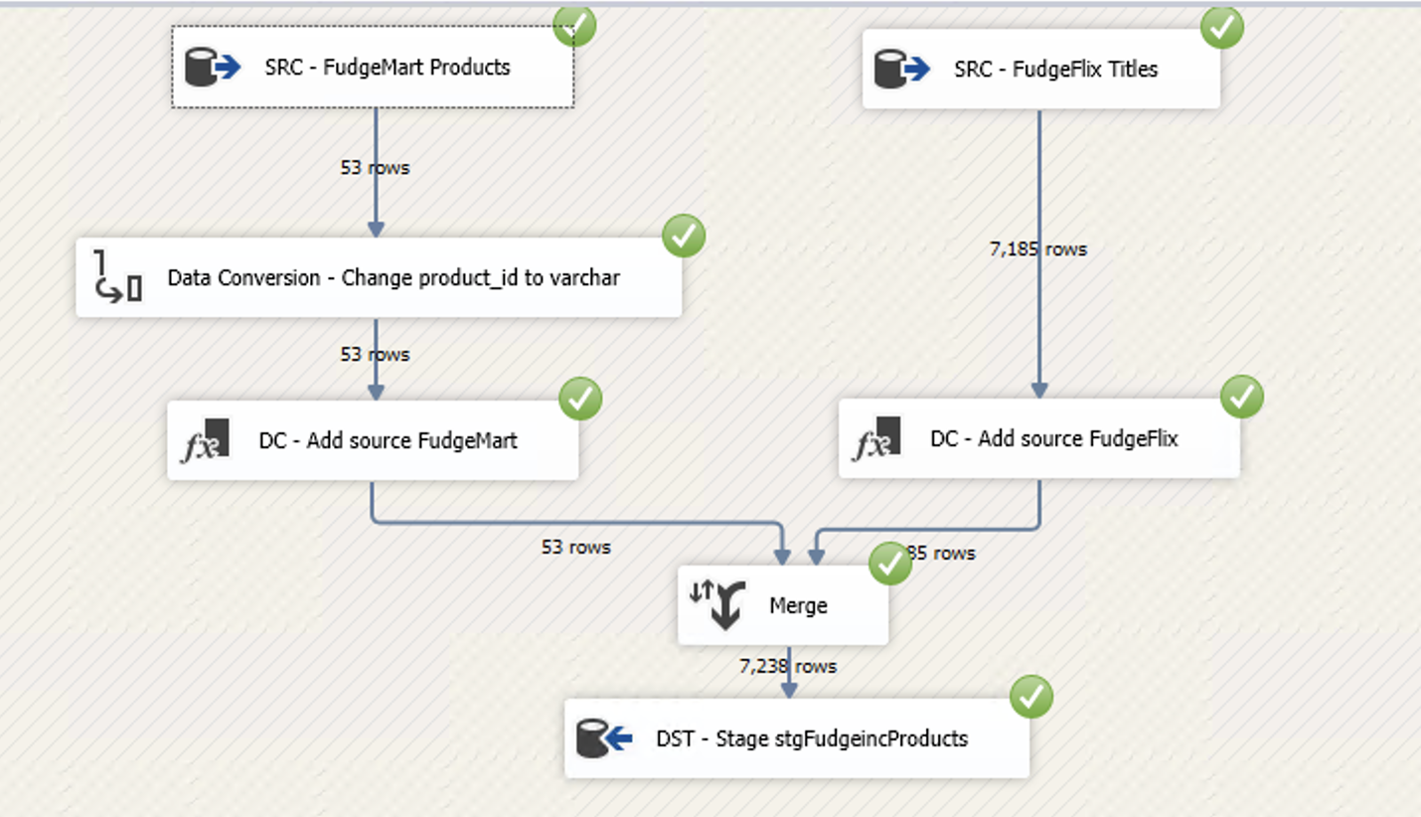

* 1. Dataflow – OLTP to Stage Customers

* 1. Dataflow – OLTP to Stage Shippers

* 1. Dataflow – OLTP to Stage OrderFulfill

1. DW OrderFulfill
   1. SSIS Package to load to DW from Stage

* 1. Dataflow – Stage Products to DW Products

* 1. Dataflow – Stage Customers to DW Customers

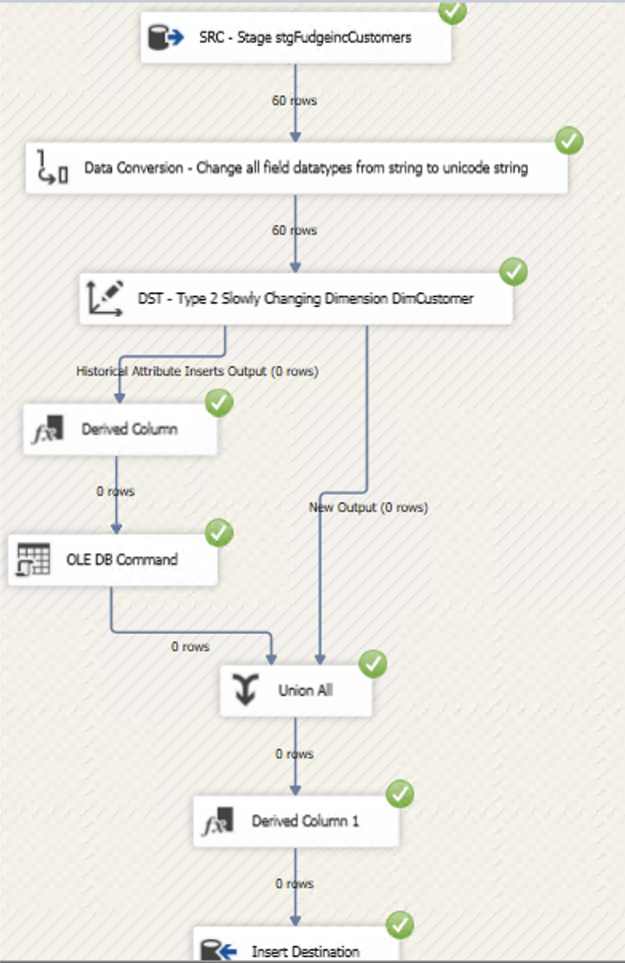

* 1. Dataflow – Stage Shippers to DW Shippers

* 1. Dataflow – Stage OrderFulfill to DW FactOrderFulfill

